OrientDB Installation Guide

# 1. Download OrientDB

- Access the link below and select the version compatible with your operating system to download OrientDB

<https://orientdb.org/download>

# 2. Configuration

- After downloading, we have a .zip file, which we then extract into a folder.

- Remember the folder path to declare it as an environment variable in “Environment Variables”.

- declare in “Path”



# 3. Start server

- Open Command Prompt and start the server.bat file in the OrientDB directory.

- This message appears when you start OrientDB for the first time.

- It prompts you to set a password for the root account. This is an important password for administrative access in OrientDB, so you should choose a password that is memorable but also secure. If you leave it blank and press Enter, the system will automatically generate a password.

- There is an asterisk (*) in front by default, it is not something you enter.

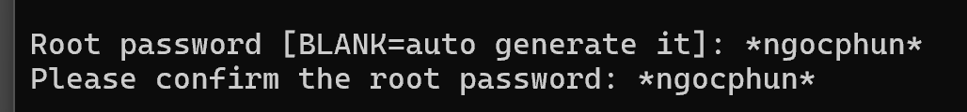

# 4. OrientDB UI

